**BIRLA INSTITUTE OF TECHNOLOGY AND SCIENCE, PILANI**

Batch No. :

**DEPARTMENT OF COMPUTER SCIENCE AND INFORMATION SYSTEMS**

**Artificial Intelligence (BITS F444/ CS F407)**

**I Semester 2019-20**

**Programming Assignment-1**

**Coding Details**

**(September 10, 2019)**

*Instruction: Type the details precisely and neatly*

1. ID 2019H1030023P
2. Name Subhashis Dhar
3. Mention the names of Submitted files:
   1. Actions.py
   2. BFS.py
   3. Environment.py
   4. Main.py
   5. Node.py
   6. Scrolltextarea.py
   7. Vaccumcleaner.py
4. Total number of submitted files: 7
5. Name of the folder: 2019H1030023P_CS_F407_A_1
6. Have you checked that all the files you are submitting have your name in the top? Yes
7. Have you checked that all the files you are submitting are in the folder as specified in 4 (and no subfolder exists)? Yes
8. Problem formulation
   1. State representation:

State is represented by a nxn grid and tuple consisting of x and y co-ordinates of vacuum cleaner

* 1. How is the Initial state generated?

In initial state, the nxn grid is initialized to 0, denoting no dirt.

* 1. What is the goal state?

Nxn grid will contain all 0s

* 1. Are there more than one goal states?

no

* 1. If yes, then describe all the goal states
  2. State representation in Python (name the construct and give one small example of a state)

class Environment():

    def __init__(self, action, n=10, vacCleanerX=0, vacCleanerY=0):

        self.n = n

        self.board = [[0 for x in range(n)] for j in range(n)]

        self.vacCleanerX = vacCleanerX

        self.vacCleanerY = vacCleanerY

        self.action = action

[0, 0, 0, 0, 1]

[0, 1, 1, 0, 1]

[0, 0, 0, 0, 0]

[0, 0, 0, 0, 0]

[0, 0, 0, 0, 1] 0,0,Actions.MD

1. Successor function description

Successor function takes state and action performed as input. Based on the action, it creates a deepcopy of the previous state with the action performed. For eg, if action is move left, the y coordinate of vacuum cleaner is decreased.

If action is suck dirt then the bit at grid[x][y] is changed to 1

1. BFS (T1) details
   1. Is the search applied on tiles or on states?

states

* 1. Error handling and reporting (yes/No): yes
  2. List the errors handled: invalid value of n and probability of dirt
  3. Data Structure description for the tree node (in maximum two lines):

1. class Node:
2. def __init__(self,env,parent):
3. self.env = env
4. self.parent = parent
   1. Code status (implemented fully/ partially/ not done)

Implemented fully

* 1. Maximum depth reached before the failed memory allocation, if happened any?

n/A

* 1. Maximum room size you are able to handle to reach the goal state within available memory and reasonable time: 10x10
  2. Other limitations of the technique: dirt percentage value should be decreased as room size increases , or else this method requires more time

1. IDS (T2) details:
   1. Code status (implemented fully/ partially/ not done)

Not done

* 1. Is the search applied on tiles or on states?
  2. Error handling and reporting (yes/No):
  3. List the errors handled:
  4. Data Structure description for the tree node (in maximum two lines):
  5. Maximum depth reached before the failed memory allocation, if happened any?
  6. Maximum room size you are able to handle to reach the goal state within available memory and reasonable time:
  7. Other limitations of the technique:

1. GUI details
   1. Created the GUI ?(yes/ N0): yes
   2. Have you created it according to the specifications?(yes/No) yes
   3. Which module of Python is used for creating graphics? tkinter
   4. Is this under the standard Python library or not? yes
   5. If not, why?
   6. Are the window panes working independently? yes
2. Graphics details:
   1. Is turtle/PyQT graphics working fine for movement of the intelligent vacuum cleaner? yes
   2. How are you creating the room tiles? yes
   3. How are you showing the dirt? yes
   4. How are you showing the resting position of the vacuum cleaner? yes
   5. Are you showing the movement of the vacuum cleaner (turtle cursor) as the execution of T1 goes on? Why or why not? yes
   6. Are you showing the movement of the vacuum cleaner (turtle cursor) as the execution of T2 goes on? Why or why not? Not implemented
   7. Which functions of Matplotlib are you using? Plot,title,xlabel,ylabel
   8. Are you using any other library such as NUMPY other than the standard Python, PyQT5 and Matplotlib?

no

* 1. Any other details:

1. Compilation Details:
   1. Code Compiles (Yes/ No): yes
   2. Mention the .py files that do not compile:___________________________________________
   3. Any specific function that does not compile:_______________________________________
   4. Ensured the compatibility of your code with the specified Python version(yes/no) yes
   5. Instructions for compilation of your files mentioning the multi file compilation process used by you (We may use the replica of these for compiling your files while evaluating your code)
2. Driver Details: Does it take care of the options specified earlier(yes/no):yes
3. Execution status (describe in maximum 2 lines) Program implements only BFS. We need to first input values for n and dirt percentage. Then generate dirt and run BFS
4. Output Details
   1. Copy and paste the output of four graphs G1-G4 here

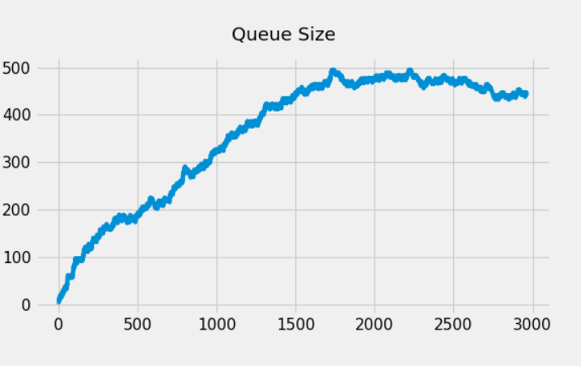

G1

G2

G3

G4

Write some more details here for the above graphs, if needed

* 1. Write the following values computed by you (refer the details of R1-R11 in the assignment document). Use appropriate units for the values

R1: R2: R3: R4:

R5: R6: R7: R8:

R9: R10: R11: R12:

1. Declaration: I, Subhashis Dhar declare that I have put my genuine efforts in creating the python code for the given programming assignment and have submitted only the code developed by me. I have not copied any piece of code from any source. If the code is found plagiarized in any form or degree, I understand that a disciplinary action as per the institute rules will be taken against me and I will accept the penalty as decided by the department of Computer Science and Information Systems, BITS, Pilani.

ID 2019H1030023P Name: Subhashis Dhar

Date:10/9/19

******************************************************************************* Should not exceed FOUR pages